**SEQUENCE DIAGRAMS**

**Sequence Diagram 1: SWITCH POWER BUTTON ON**

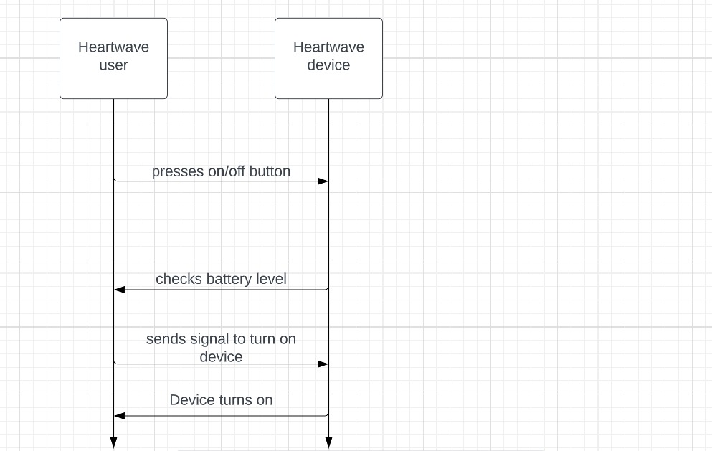

**Sequence Diagram 2: SWITCH POWER BUTTON OFF**

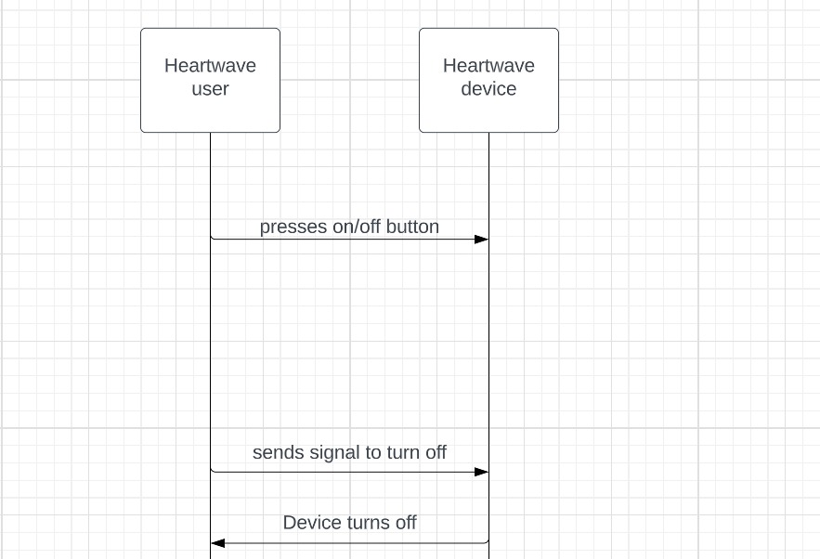

**Sequence Diagram 3: START A NEW SESSION**

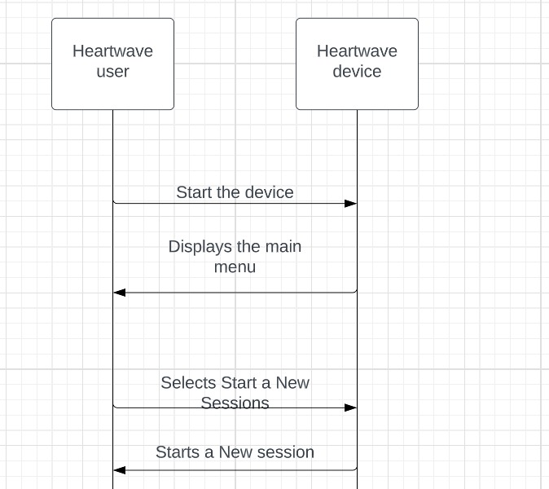

**Sequence Diagram 4: END A SESSION**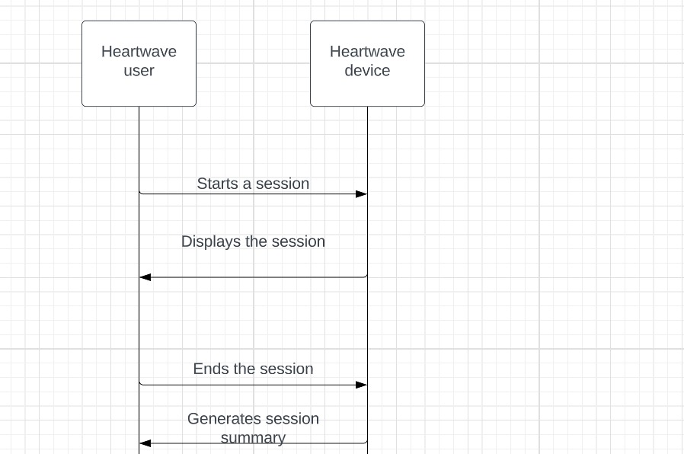

**Sequence Diagram 5: USER CHANGES CHALLENGE LEVEL**

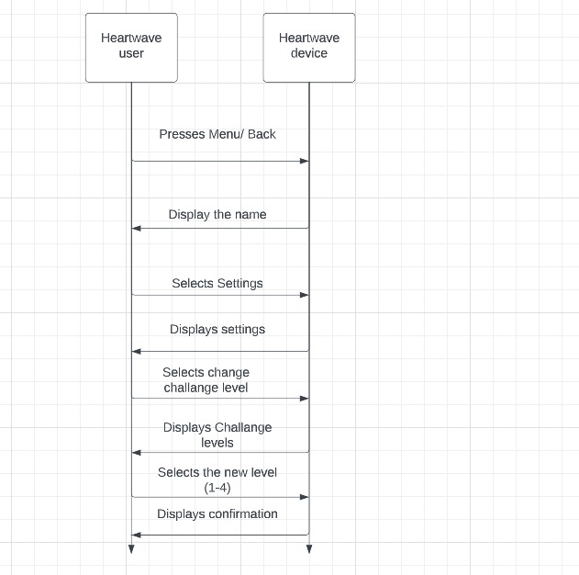

**Sequence Diagram 6: BREATH PACER**

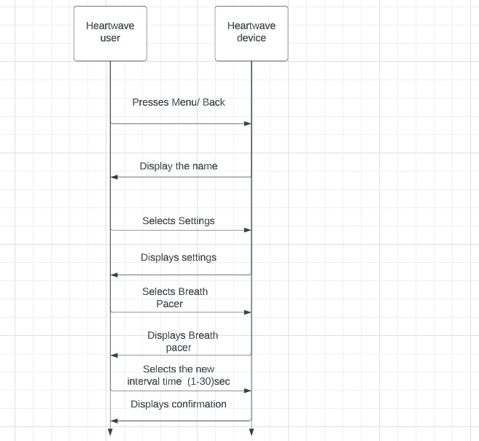

**Sequence Diagram 7: VIEW LOG/HISTORY OF SESSIONS**

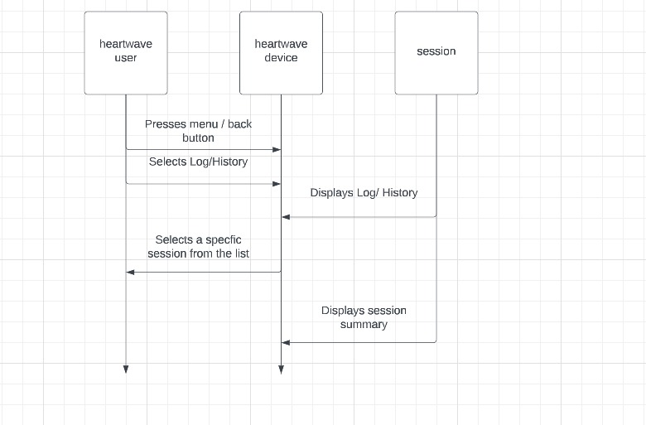

**Sequence Diagram 8: DELETE A SESSION**

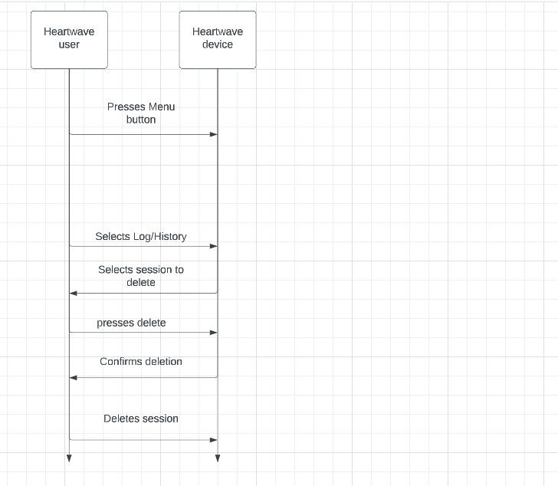

**Sequence Diagram 9: RESETTING DEVICE**

